Putting it Together
First, pick a network architecture; choose the layout of your neural network, including how many hidden units in each layer and how many layers in total you want to have.
- Number of input units = dimension of features x(i)
- Number of output units = number of classes
- Number of hidden units per layer = usually more the better (must balance with cost of computation as it increases with more hidden units)
- Defaults: 1 hidden layer. If you have more than 1 hidden layer, then it is recommended that you have the same number of units in every hidden layer.
Training a Neural Network
- Randomly initialize the weights
- Implement forward propagation to get hΘ(x(i)) for any x(i)
- Implement the cost function
- Implement backpropagation to compute partial derivatives
- Use gradient checking to confirm that your backpropagation works. Then disable gradient checking.
- Use gradient descent or a built-in optimization function to minimize the cost function with the weights in theta.
When we perform forward and back propagation, we loop on every training example:
for i = 1:m,
Perform forward propagation and backpropagation using example (x(i),y(i))
(Get activations a(l) and delta terms d(l) for l = 2,...,L
The following image gives us an intuition of what is happening as we are implementing our neural network:
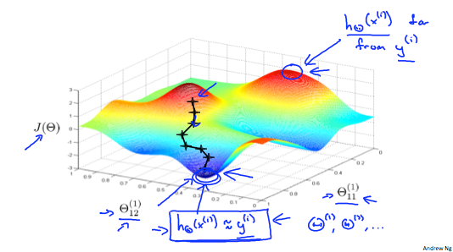
Ideally, you want hΘ(x(i)) ≈ y(i). This will minimize our cost function. However, keep in mind that J(Θ) is not convex and thus we can end up in a local minimum instead.

